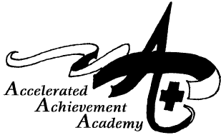
Charter Academy of the Redwoods
Notice of Special Meeting
Fullerton Classroom

Join Zoom Meeting

https://us04web.zoom.us/j/79421122651?pwd=

t18LZmbxxmFDgikmadW1k7RwIJgqEa.1

Meeting ID: 794 2112 2651 Passcode: W53BF9

(707) 467-0500
February 15, 2025 * 6:00 p.m. Open Session

Welcome! The agenda is provided for this special meeting of the Board of Directors of Charter Academy of the Redwoods, a non-profit public benefit corporation. All business of the Board is limited to these items and is conducted to fulfill the mission of preparing students for a successful future in safe, challenging, well-managed charter schools. If you wish to speak or present written comments, please notify the chairperson. A copy of any items that are identified as “back-up” is available upon request.

Welcome and Opening
  - Call to Order/Roll Call
  - Adoption of Agenda

II. Regular Meeting—Action Items

  - Approval of Board Resolution No. 04-21/22— The Directors are requested to approve the terms and conditions of the Charter Academy of the Redwoods authorizing teleconferenced board meeting pursuant to AB 361. (back-up)

Public Comment for Items Not on the Agenda—The Board reserves 10 minutes for members of the public to address the Board on items not on the agenda and within its jurisdiction. The Board is prohibited by law from taking action on matters not on the agenda, but may ask questions to clarify the speaker's comment, briefly answer questions, and refer the speaker to follow up with a specific staff member.

IV. Next Regular Meeting—Tuesday, March 8, 2022@ 6:00 p.m. @ Redwood Academy of Ukiah

V. Adjournment

